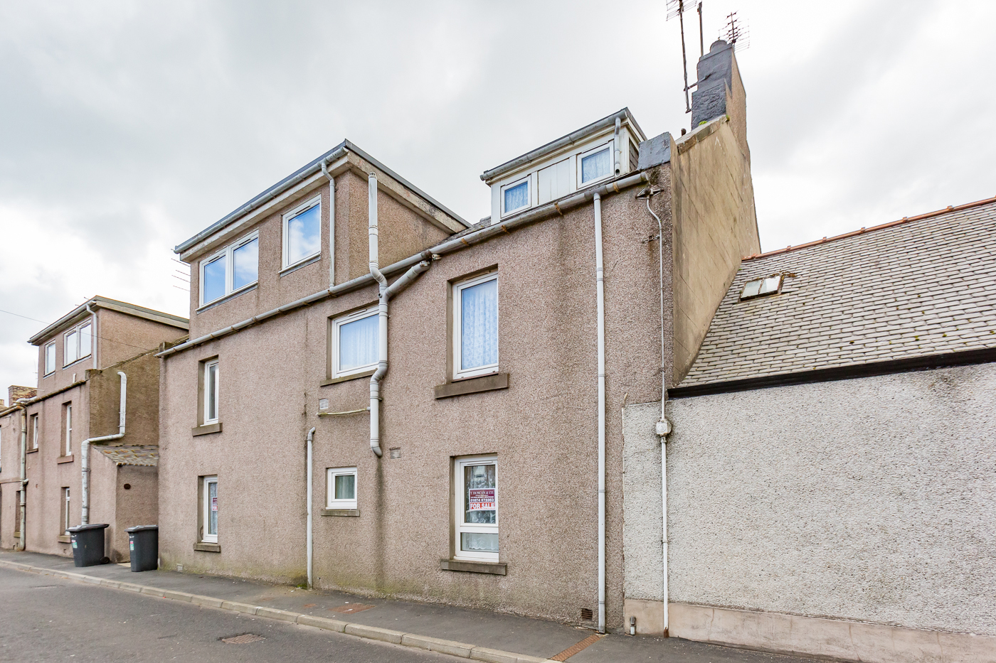
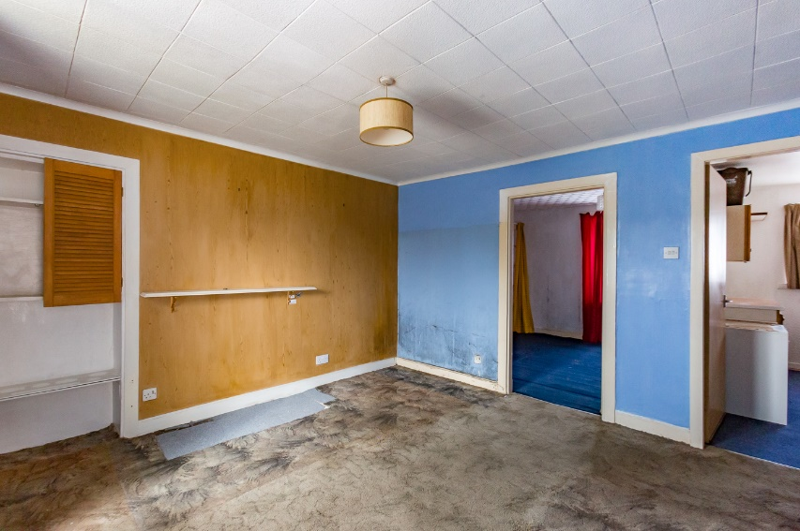
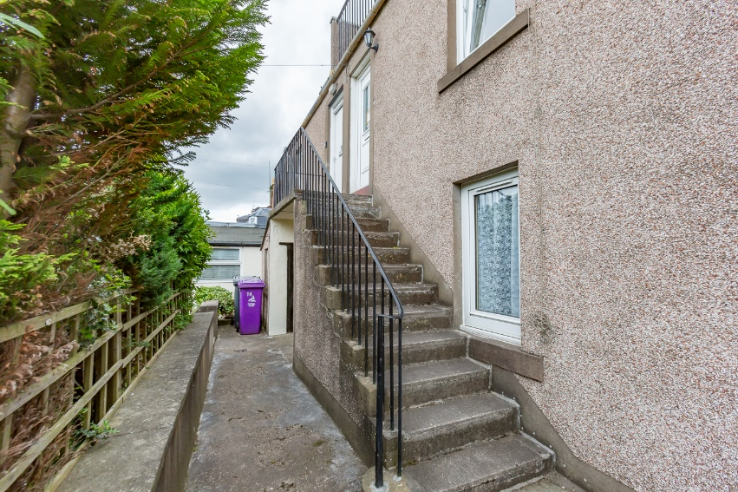
Flat 1, 14 India Street | Montrose | DD10 8PG
Offers Over £55,000

T. DUNCAN & CO.
Solicitors ● Estate Agent
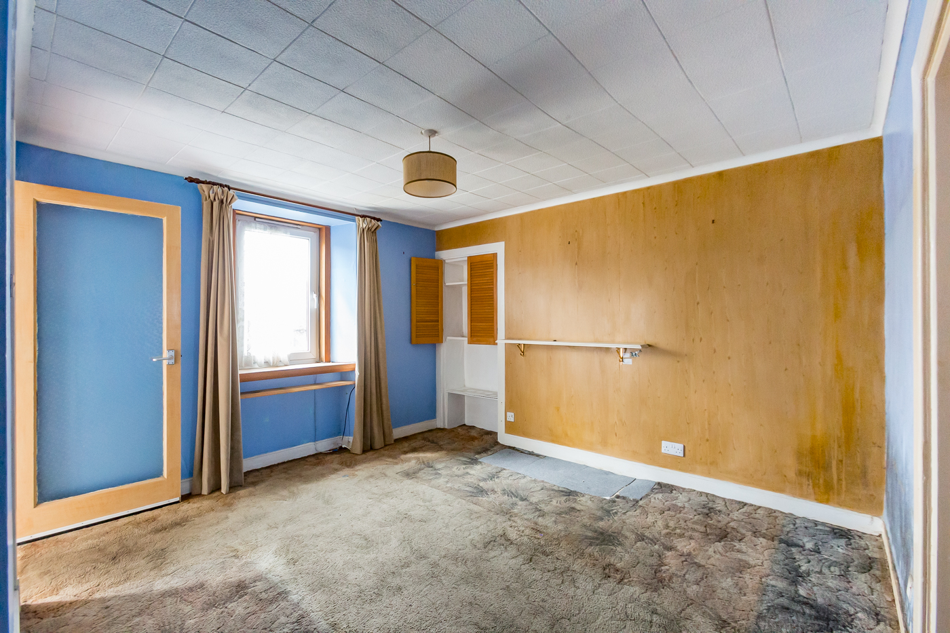
Requiring a degree of modernisation this 2 bedroom first floor maisonette offers a great deal of potential either as a first time buy or buy-to-let investment. The property has double glazing and comprises of a lounge, kitchen, 1 bedroom on the first floor with the 2 bedroom and bathroom upstairs.
Outside there is access to the mutual drying green & water closet and one private cellar

Flat 1, 14 India Street | Montrose | DD10 8PG
Offers Over £55,000

- Bedroom 2: 11’6 x 9’3 (3.53m x 2.83m)
- Bathroom: 6’3 x 6’4 (1.93m x 1.95m)
- Private Cellar
- First floor maisonette
- Lounge: 11’10 x 11’8 (3.65m x 3.61m)
- Kitchen: 6’7 x 10’3 (2.04m x 3.15m)
- Bedroom 1: 8’9 x 10’3 (2.71m x 3.13m)

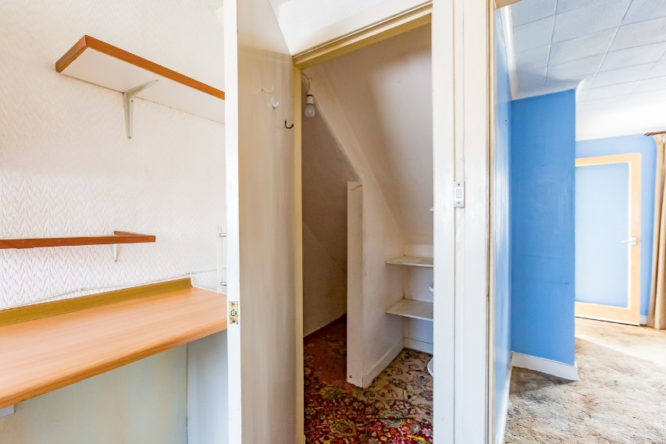
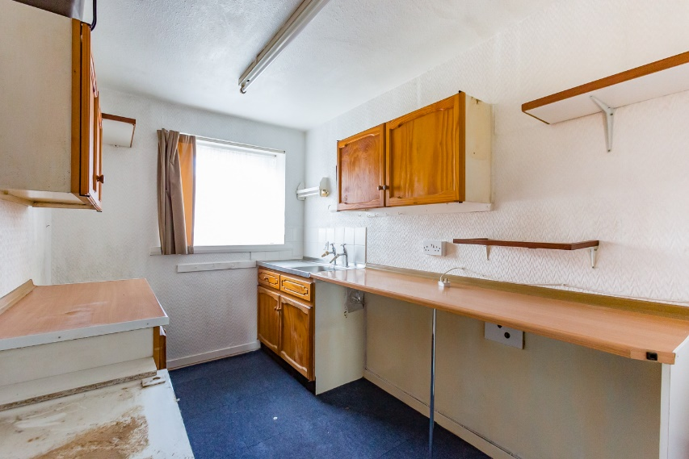

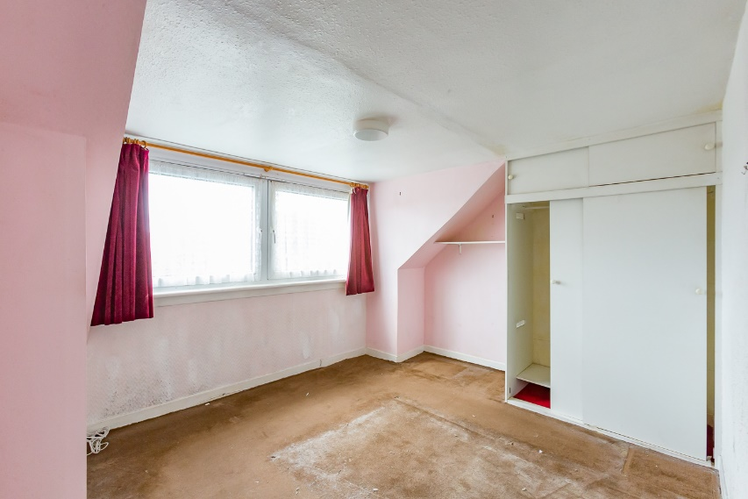
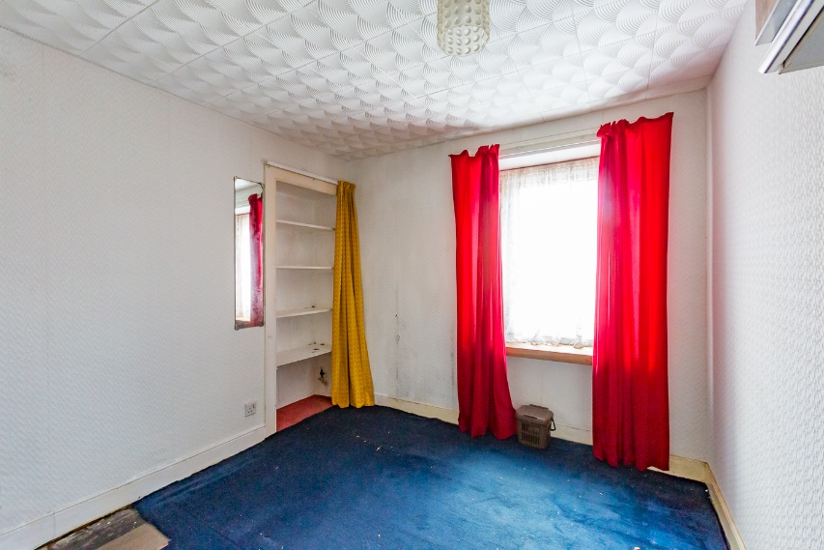

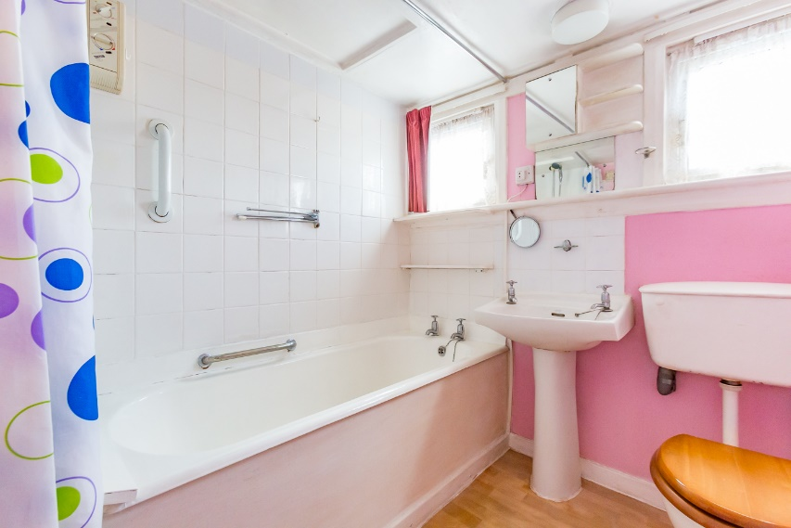
Entry into a hallway where there is a storage cupboard and a glass panel door leading into the lounge.
The lounge is rear facing and there is a shelved alcove. A door from the lounge leads into the front facing kitchen which is fitted to base and wall units with coordinating work surfaces incorporating a stainless-steel sink, plumbed space for an automatic washing machine and a walk in under stairs cupboard which has shelving and light.
Bedroom 1 has a front facing window and shelved alcove.
A staircase from the hallway leads to the upper floor and at the top of the stairs there is a shelved cupboard and access into bedroom 2 which has a rear facing window and a double shelved and hanging wardrobe with overhead storage.
The bathroom has two front facing windows and comprises a three piece white bathroom suite with an over the bath shower, tiled to bath, shower and wash hand basin area and there is a wall heater.
Mutual drying green & water closet and one private cellar.

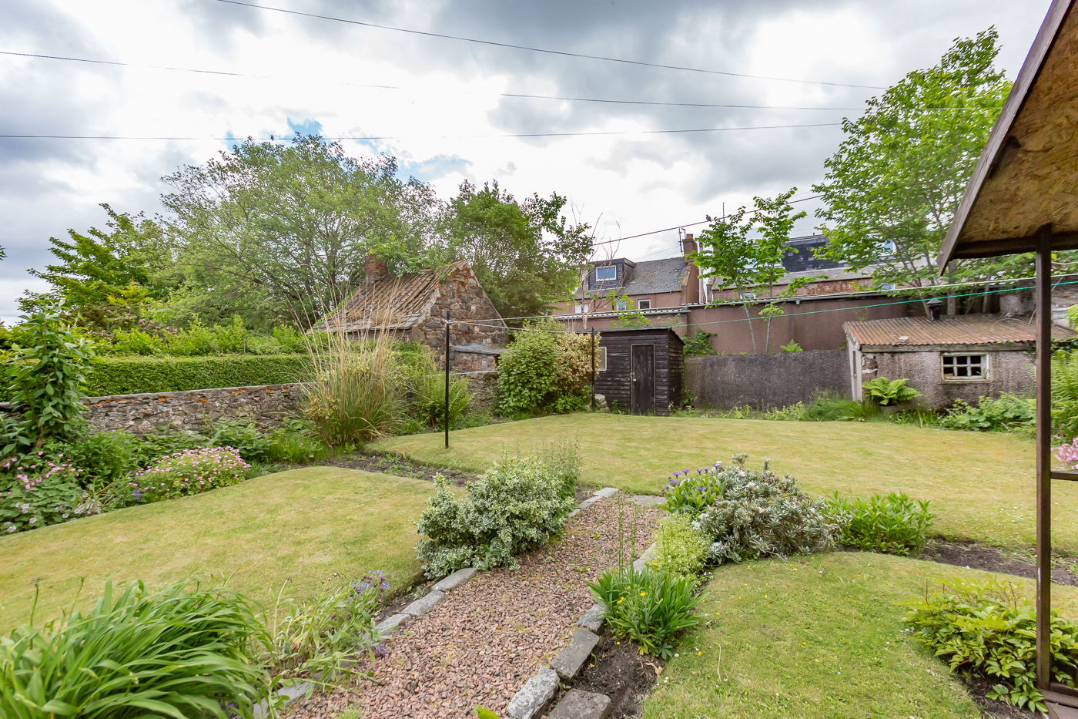
Services: Electric and Double Glazing

Fixtures & Fittings: Carpets, blinds & light fittings incl.

Local Authority: Angus Council

Council Tax Band: A

Post Code: DD10 8PG

Home Report: Contact our Property department if you wish us to e-mail a copy of the Report free of charge or to send the URL for you to download

Viewing: By arrangement through agent
G
T. DUNCAN & CO.
Solicitors ● Estate Agents

143 High Street, Montrose, DD10 8QN
Telephone: 01674 672353
Fax: 01674 678345
E-mail: mpc@tduncan.com
www.tduncan.com
N.B. The foregoing particulars are believed to be accurate. They have been carefully prepared for the guidance of intending purchasers but their accuracy is not guaranteed and they do not form part of any contract of Sale. All measurements are approximate and have been made using an electronic measuring device. The measurements may, therefore, be subject to a slight margin of error. Should the size of any measurement be essential then intending offerers are strongly advised to check carefully for themselves. Prospective purchasers are requested to note their interest with the selling agents in order that they may be advised of any closing date etc. No member of staff of T. Duncan & Co. has authority to give any undertaking or assurance in respect of this or any other property. Please note that none of the services/systems have been tested by our clients or their agents and no warranty is given regarding the condition of same. Please note that this a draft Schedule.
For a free no obligation valuation of your own property call our Property Department on 01674 672353.

